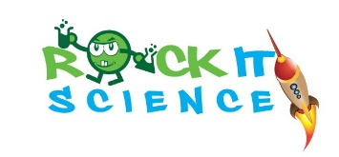

Rock it Science, run by fully qualified Science teachers, offer extra-curricular activities that teach children about the wonder of Science in an engaging and informative way. Each week children will get to the opportunity to explore different science topics through discovery based learning activities. They will watch some amazing demonstrations and get to do their own exciting hands on experiments. These are designed to get children to make predictions and explain their observations. The very essence of Science!
This term we will study cool colour changes, wild weather, make crazy kinetic sand, feel the forces with magnificent magnets, see marvelous mini-beasts and then build and test the strength of a spaghetti tower!

We will be offering two classes:

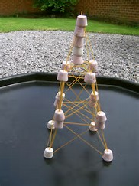

- The Little Einstein’s for children in Years 1
- The Exploring Scientist’s for children in Years 2-6
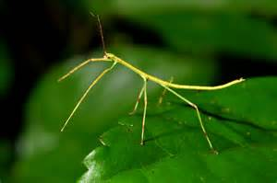
TOPICS: | A wide range of Biology, Chemistry, Physics and Engineering concepts covered
DAY: | WEDNESDAY
DATES: | 19th, 26th April  3rd, 10th, 17th, 24th May (Until Ramadan starts)
TIMINGS: | 2:30 – 3:15 PM (45 MINS)
GRADE LEVEL: | YR 1 – 6
COST: | 65 AED per session (Total cost of 6 SESSIONS is 390 AED)
CONTACT PERSON: | Nichola Fisher - BSc Physiology (Hons), PGCE Science  0503948251  Email: info@rockitscienceparties.com  www.rockitscienceparties.com
REGISTRATION: | Please complete the booking form to register your son/daughters place.  We will also be available at the sign up session at DBS on the 9th of April.  https://goo.gl/forms/yQQ6DeEylhDKRIdF3

